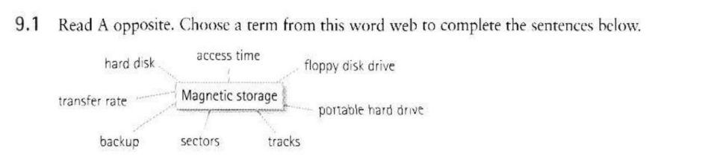1. The first rule of data storage is to make a **backup** of all important files. 2. A **floppy disk drive** is slower than a hard drive and can only hold 1.44 MB disks. 3. The **hard disk** inside your PC is made of aluminium alloy covered with a magnetic coating. This makes the disk itself a rigid plate, hence its name.

4. The **tracks** are circles around a disk and the **sectors** are segments within each circle. 5. This hard drive is a 60 GB IBM model with a fast **transfer rate** of 8ms.

6. The **access time** is the rate of transmission of data from the disk to the CPU. This is usually described in megabytes per second.

7. Apple’s iPod music player can double as a **portable hard drive** for transporting computer data.RENZO NEYRA QUESQUEN

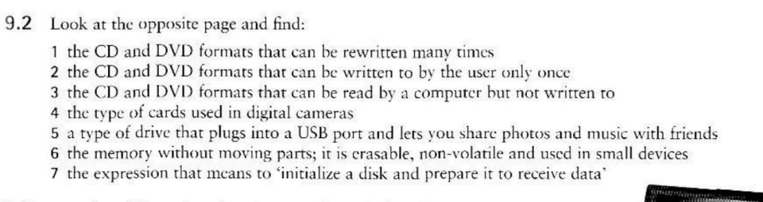

1. CD – RW and DVD-RW or DVD+RW

2. CD – R and DVD-R or DVD+RW

3. CD – ROMs and DVD-ROM

4. COMPACTFLASH CARDS

5. FLASH DRIVES

6. FLASH MEMORY

7. FORMAT THE DISK

RENZO NEYRA QUESQUEN

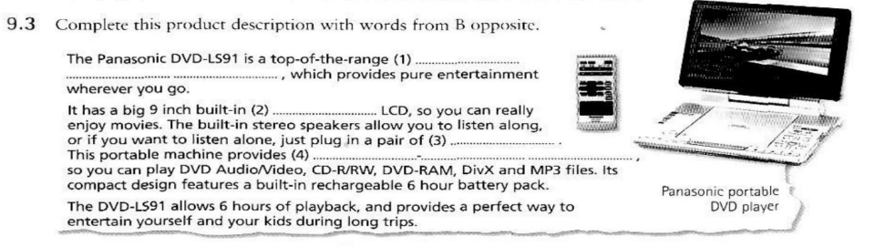

The Panasonic DVD-LS91 is a top-of-the-range portable DVD player, which provides pure entertainment wherever you go. It has a big 9-inch built-in widescreen LCD, so you can really enjoy movies. The built-in stereo speakers allow you to listen along, or if you want to listen alone, just plug in a pair of headphones. This portable machine provides versatility, so you can play DVD Audio/Video, CD-R/RW, DVD-RAM, DivX, and MP3 files. Its compact design features a built-in rechargeable 6-hour battery pack.

RENZO NEYRA QUESQUEN